GIT COMMANDS
git init
git status
git add file.txt
git commit -m "Initial commit"

git branch feature1
git checkout feature1
git add folder/
git commit -m "Added folder"

git push origin feature1

SQL QUERIES

mysql> CREATE DATABASE fullstack;
Query OK, 1 row affected (0.03 sec)

mysql> USE fullstack;
Database changed
mysql> CREATE TABLE Student (
-> VTU_Number VARCHAR(20) PRIMARY KEY,
-> Name VARCHAR(100),
-> Email VARCHAR(100),
-> Phone VARCHAR(15),
-> Department VARCHAR(50)
-> );
Query OK, 0 rows affected (0.05 sec)

mysql> CREATE TABLE Course (
-> Course_Code VARCHAR(10) PRIMARY KEY,
-> Course_Name VARCHAR(100),
-> Faculty_Id INT,
-> Student_ID VARCHAR(20),
-> Faculty_Email VARCHAR(100),
-> FOREIGN KEY (Student_ID) REFERENCES Student(VTU_Number)
-> );
Query OK, 0 rows affected (0.08 sec)

mysql> INSERT INTO Student VALUES
-> ('1MS23CS001','Arjun','arjun@mail.com','9845011223','CSE'),
-> ('1MS23CS002','Sneha','sneha@mail.com','9845022334','IT'),
-> ('1MS23CS003','Rahul','rahul@mail.com','9845033445','CSE'),
-> ('1MS23CS004','Priya','priya@mail.com','9845044556','ECE'),
-> ('1MS23CS005','Amit','amit@mail.com','9845055667','IT');
Query OK, 5 rows affected (0.03 sec)
Records: 5 Duplicates: 0 Warnings: 0

mysql> INSERT INTO Course VALUES
-> ('CS101','DBMS',101,'1MS23CS001','smith@vtu.edu'),
-> ('IS202','DS',102,'1MS23CS002','jones@vtu.edu'),
-> ('CS103','OS',101,'1MS23CS003','smith@vtu.edu'),
-> ('EC301','DE',103,'1MS23CS004','kumar@vtu.edu'),
-> ('IS204','Web',104,'1MS23CS005','leila@vtu.edu');
Query OK, 5 rows affected (0.02 sec)
Records: 5 Duplicates: 0 Warnings: 0

mysql> ELECT * FROM Student;
ERROR 1064 (42000): You have an error in your SQL syntax; check the manual that corresponds to your MySQL server version for the right syntax to use near 'ELECT * FROM Student' at line 1
mysql> SELECT * FROM Student;
+------------+-------+----------------+------------+------------+
| VTU_Number | Name | Email | Phone | Department |
+------------+-------+----------------+------------+------------+
| 1MS23CS001 | Arjun | arjun@mail.com | 9845011223 | CSE |
| 1MS23CS002 | Sneha | sneha@mail.com | 9845022334 | IT |
| 1MS23CS003 | Rahul | rahul@mail.com | 9845033445 | CSE |
| 1MS23CS004 | Priya | priya@mail.com | 9845044556 | ECE |
| 1MS23CS005 | Amit | amit@mail.com | 9845055667 | IT |
+------------+-------+----------------+------------+------------+
5 rows in set (0.01 sec)

mysql> SELECT COUNT(*) FROM Student;
+----------+
| COUNT(*) |
+----------+
| 5 |
+----------+
1 row in set (0.01 sec)

mysql> SELECT * FROM Student ORDER BY VTU_Number DESC;
+------------+-------+----------------+------------+------------+
| VTU_Number | Name | Email | Phone | Department |
+------------+-------+----------------+------------+------------+
| 1MS23CS005 | Amit | amit@mail.com | 9845055667 | IT |
| 1MS23CS004 | Priya | priya@mail.com | 9845044556 | ECE |
| 1MS23CS003 | Rahul | rahul@mail.com | 9845033445 | CSE |
| 1MS23CS002 | Sneha | sneha@mail.com | 9845022334 | IT |
| 1MS23CS001 | Arjun | arjun@mail.com | 9845011223 | CSE |
+------------+-------+----------------+------------+------------+
5 rows in set (0.00 sec)

mysql> SELECT * FROM Student WHERE Department='CSE';
+------------+-------+----------------+------------+------------+
| VTU_Number | Name | Email | Phone | Department |
+------------+-------+----------------+------------+------------+
| 1MS23CS001 | Arjun | arjun@mail.com | 9845011223 | CSE |
| 1MS23CS003 | Rahul | rahul@mail.com | 9845033445 | CSE |
+------------+-------+----------------+------------+------------+
2 rows in set (0.01 sec)

mysql> SELECT s.VTU_Number, c.Course_Name, c.Faculty_Email
-> FROM Student s
-> INNER JOIN Course c ON s.VTU_Number = c.Student_ID;
+------------+-------------+---------------+
| VTU_Number | Course_Name | Faculty_Email |
+------------+-------------+---------------+
| 1MS23CS001 | DBMS | smith@vtu.edu |
| 1MS23CS002 | DS | jones@vtu.edu |
| 1MS23CS003 | OS | smith@vtu.edu |
| 1MS23CS004 | DE | kumar@vtu.edu |
| 1MS23CS005 | Web | leila@vtu.edu |
+------------+-------------+---------------+
5 rows in set (0.01 sec)

mysql> SELECT Course_Name, COUNT(*)
-> FROM Course
-> GROUP BY Course_Name;
+-------------+----------+
| Course_Name | COUNT(*) |
+-------------+----------+
| DBMS | 1 |
| OS | 1 |
| DE | 1 |
| DS | 1 |
| Web | 1 |
+-------------+----------+
5 rows in set (0.01 sec)

mysql> CREATE TABLE Faculty_Courses (
-> Faculty_Id INT,
-> Course_Name VARCHAR(100)
-> );
Query OK, 0 rows affected (0.04 sec)

mysql> INSERT INTO Faculty_Courses
-> SELECT Faculty_Id, Course_Name
-> FROM Course
-> WHERE Faculty_Id = 101;
Query OK, 2 rows affected (0.02 sec)
Records: 2 Duplicates: 0 Warnings: 0

mysql> UPDATE Student
-> SET Phone = CONCAT('+91', Phone)
-> WHERE Department='CSE'
-> LIMIT 5;
Query OK, 2 rows affected (0.02 sec)
Rows matched: 2 Changed: 2 Warnings: 0

mysql> START TRANSACTION;
Query OK, 0 rows affected (0.00 sec)

mysql> INSERT INTO Student VALUES
-> ('1MS23CS006','Kiran','kiran@mail.com','9999999999','CSE');
Query OK, 1 row affected (0.00 sec)

mysql> SAVEPOINT sp1;
Query OK, 0 rows affected (0.01 sec)

mysql> INSERT INTO Student VALUES
-> ('1MS23CS007','Meera','meera@mail.com','8888888888','IT');
Query OK, 1 row affected (0.00 sec)

mysql> ROLLBACK TO sp1;
Query OK, 0 rows affected (0.01 sec)

mysql> COMMIT;
Query OK, 0 rows affected (0.01 sec)

mysql> DELIMITER $$
mysql>
mysql> CREATE FUNCTION multiply_numbers(a INT, b INT)
-> RETURNS INT DETERMINISTIC
-> BEGIN
-> RETURN a * b;
-> END$$
Query OK, 0 rows affected (0.04 sec)

mysql>
mysql> DELIMITER ;
mysql>
mysql> SELECT multiply_numbers(5,4);
+-----------------------+
| multiply_numbers(5,4) |
+-----------------------+
| 20 |
+-----------------------+
1 row in set (0.01 sec)
Pictures
Session 2
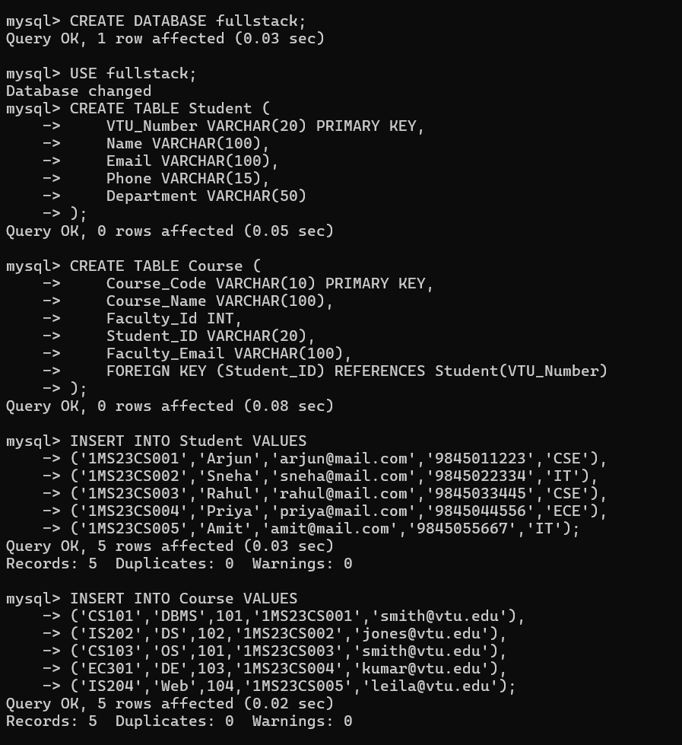

Session 3
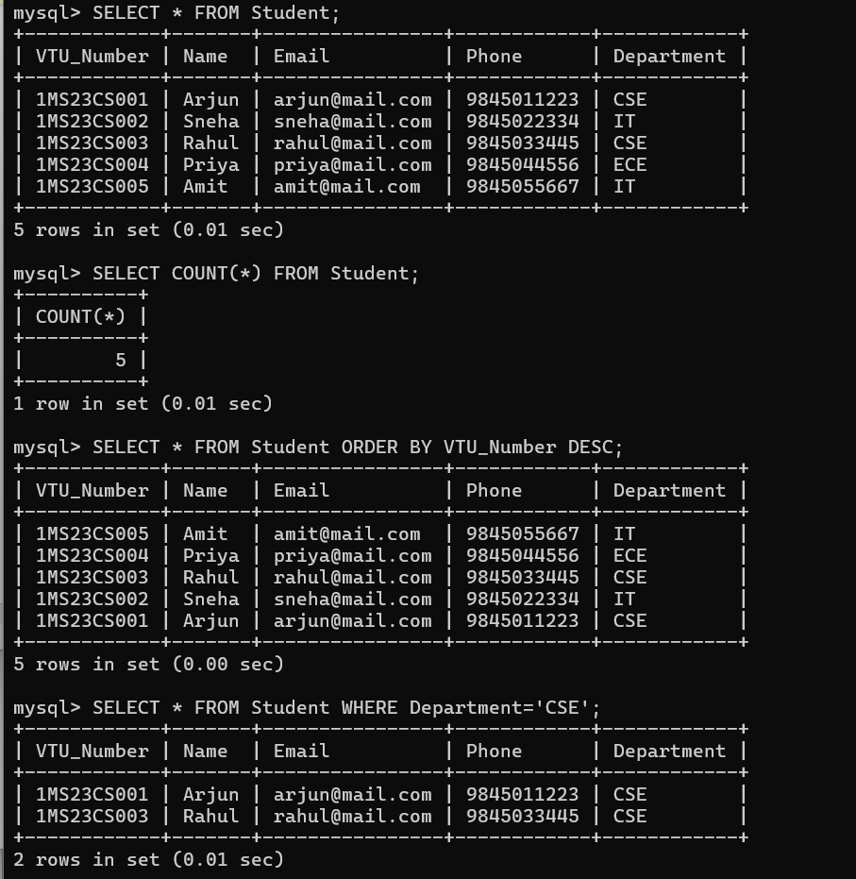
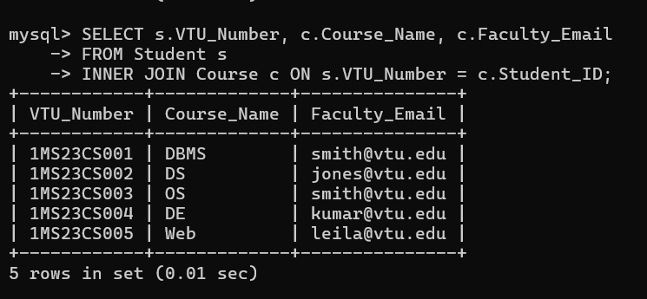
Session 4
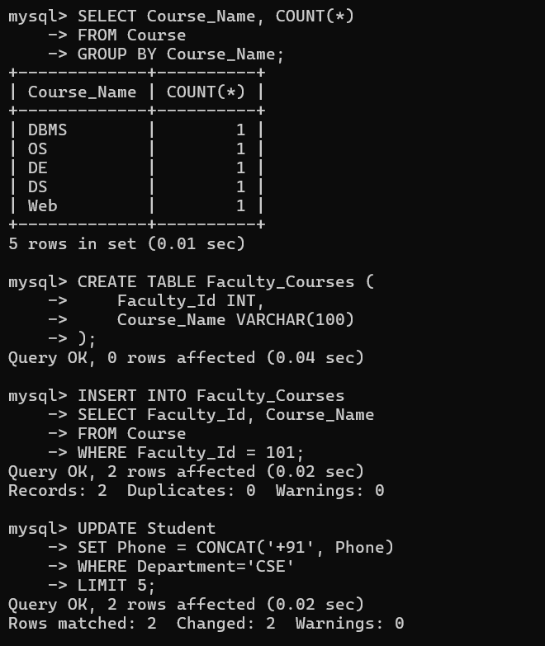
Session 5
